**AUTOMATIC SHUTTER OPENING**

**A PROJECT WORK I REPORT**

**Submitted By**

## SARAN S

**(21ECR181)**

## SARAVANAKUMAR P

**(21ECR183)**

## VANISRI K

### (21ECR219)

***in partial fulfilment of the requirements***

***for the award of the degree***

***of***

**BACHELOR OF ENGINEERING**

**IN**

**ELECTRONICS AND COMMUNICATION ENGINEERING**

**DEPARTMENT OF ELECTRONICS AND COMMUNICATION fjnnk bobobfbbiubiuiui ENGINEERING**



**KONGU ENGINEERING COLLEGE**

**(Autonomous)**

**PERUNDURAI, ERODE – 638 060**

**MAY 2024**

## DEPARTMENT OF ELECTRONICS AND COMMUNICATION khbk ENGINEERING

## KONGU ENGINEERING COLLEGE

**(Autonomous)**

**PERUNDURAI ERODE – 638060**

**MAY 2024**

## BONAFIDE CERTIFICATE

This is to certify that the project work I entitled **“AUTOMATIC SHUTTER OPENING”**  is the bonafide record of project work done by **SARAN S (21ECR181), SARAVANAKUMAR P (21ECR183), VANISRI K (21ECR219)** in partial fulfilment of the requirements for the award of the Degree of Bachelor of Engineering in Electronics and Communication of Anna University, Chennai during the year 2023-2024.

**SUPERVISOR**  **HEAD OF THE DEPARTMENT**

**Dr. T. MEERADEVI M.E., Ph.D**., **Dr. N.KASTHURI M.E., Ph.D.,**

Professor Professor & Head

Department of ECE Department of ECE

Kongu Engineering College Kongu Enginnering College

Perundurai – 638 060. Perundurai – 638 060

**Date:**

Submitted for the sixth semester viva voce examination held on _____________.

**INTERNAL EXAMINER EXTERNAL EXAMINER**

## DEPARTMENT OF ELECTRONICS AND COMMUNICATION ENGINEERING

## KONGU ENGINEERING COLLEGE

**(Autonomous)**

**PERUNDURAI, ERODE – 638060**

**MAY 2024**

## DECLARATION

We affirm that the project work I report entitled **“AUTOMATIC SHUTTER OPENING”** being submitted in partial fulfilment of the requirements for the award ofBachelor of Engineering is the original work carried out by us . It has not formed the partof any other project report or dissertation on the basis of which a degree or award was conferred on an earlier occasion on this or any other candidate.

**Date:** (Signature of the Candidates)

**SARAN S**

**(21ECR181)**

**SARAVANAKUMAR P**

**(21ECR183)**

## VANISRI K

**(21ECR219)**

I certify that the declaration made by the above candidates is true to the best of my knowledge.

**Date:**  **Name & Signature of the Supervisor with seal**

# ABSTRACT

The design and implementation of an Automatic Shutter Opening System utilizing Arduino Uno microcontroller, HC-06 Bluetooth module and motor drivers. The system aims to provide a convenient and efficient solution for remotely controlling the opening and closing of shutters in various environments, such as homes, offices and industrial settings. It is programmed to receive commands wirelessly via Bluetooth from a mobile device or a computer, enabling users to control the shutter operation remotely. The system's software architecture includes a user-friendly interface for sending commands to the Arduino Uno, allowing users to open, close, or stop the shutter movement as desired. The proposed Automatic Shutter Opening System offers a practical and versatile solution for automating shutter control, providing users with convenience, flexibility, and enhanced functionality in various settings. The system's modular design and open-source nature make it easily customizable and adaptable to specific requirements, paving the way for broader adoption and integration into smart home and industrial automation ecosystems.

**ACKNOWLEDGEMENT**

First and foremost, we acknowledge the abundant grace and presence of the Almighty throughout different phases of the project and its successful completion.

We wish to express our hearty gratitude to our honourable Correspondent **Thiru A. K. ILANGO B.Com., M.B.A., LLB.,** and other trust members for having provided us with all necessary infrastructures to undertake this project.

We would like to express our hearty gratitude to our honourable Principal **Dr. V. BALUSAMY B.E.(Hons)., M.Tech., Ph.D.,** for his consistent encouragement throughout our college days.

We would like to express our profound interest and sincere gratitude to our respected Head of the department **Dr. N. KASTHURI M.E., Ph.D.,** for her valuable guidance.

A special debt is owed to the project coordinator **Ms. G. DEEPA M.E.,** Assistant Professor (Sr.G) and **Ms. J. CHARANYA M.E.,** Assistant Professor, Department of Electronics and Communication Engineering, for their encouragement and valuable advice that helped us to carry out the project successfully.

We would like to express our sincere gratitude to our beloved guide

**Dr. T. MEERADEVI M.E., Ph.D.,** Professor, Department of Electronics and Communication Engineering, for her ideas and suggestions, which have been very helpful to complete the project.

We are grateful to all the faculty and staff of the Department of Electronics and Communication Engineering and those who had directly and indirectly supported this project.

**TABLE OF CONTENTS**

|  |  |  |
| --- | --- | --- |
| **CHAPTER No.** | **TITLE** | **PAGE No.** |
|  | ABSTRACT | iv |
|  | ACKNOWLEDGEMENT | v |
|  | LIST OF FIGURES | viii |
|  | LIST OF ABBREVIATIONS | ix |
| **1** | **INTRODUCTION** | **1** |
| **2** | **ABOUT THE COMPANY** | **2** |
| **3** | **SYSTEM SPECIFICATION** | **3** |
|  | 3.1 HARDWARE DESCRIPTION | 3 |
|  | 3.1.1 Arduino Uno | 3 |
|  | 3.1.2 Bluetooth module (HC 06) | 4 |
|  | 3.1.3 Relay | 5 |
|  | 3.1.4 Single phase ac motor | 5 |
| **4** | **PROPOPSED METHOD** | **7** |
|  | 4.1 BLOCK DIAGRAM | 7 |
|  | 4.2 WORKING | 8 |
| **5** | **RESULTS AND DISCUSSION** | **9** |
| **6** | **CONCLUSION AND FUTURE SCOPE** | **11** |
|  | 6.1 CONCLUSION | 11 |
| **7** | 6.2 FUTURE SCOPE  **REFERENCE** | 11  **12** |

**ANNEXURE 13**

ACCEPTANCE LETTER 13

APPRECIATION LETTER 14

# LIST OF FIGURES

|  |  |  |
| --- | --- | --- |
| **FIGURE No.** | **FIGURE NAME** | **PAGE No.** |
| 3.1 | Arduino uno | 4 |
| 3.2 | Bluetooth module (HC 06) | 4 |
| 3.3 | Relay | 5 |
| 3.4 | Single phase AC motor | 6 |
| 4.1 | Block Diagram | 7 |
| 5.1 | User interface | 9 |
| 5.2 | Hardware Setup | 10 |

## 

## 

## LIST OF ABBREIVATIONS

|  |  |  |
| --- | --- | --- |
| COM | - | Communication Port |
| GND | - | Ground |
| HC | - | Host Controller |
| IDE | - | Integrated Development Environment |
| LED | - | Light Emitting Diode |
| UART | - | Universal Asynchronous Receiver/Transmitter |
| VCC | - | Voltage at Common Collector |

**CHAPTER 1**

## INTRODUCTION

In the realm of home and building automation, automatic shutters offer a blend of convenience and efficiency. This project is focused on developing a smart shutter system that can intelligently control the opening and closing of shutters. By incorporating sensors for light intensity and user preferences, along with microcontrollers for decision-making, the system aims to enhance comfort and energy efficiency. At the core of an automatic shutter opening system is a microcontroller, often an Arduino Uno or similar device, which serves as the central processing unit. This microcontroller is programmed to receive commands from various input sources, such as remote controls, timers, light sensors, or smartphone applications via Bluetooth or Wi-Fi connectivity.

Motor drivers are used to control the movement of the shutters, converting the digital signals from the microcontroller into physical motion. These drivers ensure precise and smooth operation, allowing the shutters to open and close with minimal noise and effort. Relays play a crucial role in power management and safety within the system. They help control the flow of electricity to the motors, preventing overload or damage and ensuring reliable performance over time.

By adjusting the opening and closing of shutters based on environmental conditions, automatic systems can contribute to energy efficiency in buildings. They can help regulate indoor temperatures by maximizing natural ventilation and reducing the need for artificial lighting, thus lowering energy consumption and utility costs**.** Automatic shutter opening systems can serve as part of a comprehensive security setup. By integrating with motion sensors or smart home security systems, shutters can be programmed to respond to potential threats by closing automatically.

**CHAPTER 2**

## ABOUT THE COMPANY

Name : SREE RANGAA AUTO AGENCY

Address : 9/100, Sri Selvaganapathy complex, Sree Rangaa auto agency, Mallur

Salem - 636 203.

Phone No : +91 9944244135

The Sree Rangaa Auto Agency, located in Salem, Tamil Nadu, India, focuses on automotive service and vehicle sales. Their dedication to quality is evident in their extensive range of offerings, which includes motorcycles, scooters, mopeds, and electric vehicles (EVs). They offer an automatic shutter opening system, which has proven to be incredibly convenient and efficient. This system allows for easy opening and closing of shutters, enhancing security and convenience for their office without the need for implementation on-site.

**CHAPTER 3**

## SYSTEM SPECIFICATION

### HARDWARE DESCRIPTION

#### ARDUINO UNO

The Arduino Uno is the Atmega328P microcontroller, which is responsible for executing program instructions and controlling inputs and outputs. The UNO boasts a variety of digital and analog input/output pins, making it versatile for interfacing with sensors, actuators, displays, and other electronic components. Figure 3.1 depicts 14 digital pins (of which 6 can be used as PWM outputs) and 6 analog input pins. The Uno can be powered and programmed via a USB connection to a computer. This makes it easy to upload code and interact with the board using the Arduino Integrated Development Environment (IDE). The board can be powered either via USB connection or an external power supply (e.g., battery) through a DC power jack. It also has a voltage regulator to provide stable 5V power to the microcontroller and other components. The Arduino Uno operates at a clock speed of 16MHz, providing sufficient processing power for most projects and prototypes. Arduino is an open-source platform, meaning that its hardware designs, software libraries, and development tools are freely available for modification and distribution. Arduino programming is based on a simplified version of C/C++, making it accessible to beginners while still offering flexibility and power for advanced users. The Arduino IDE provides an easy-to-use interface for writing, compiling and uploading code to the board.

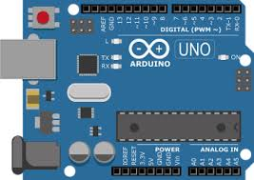

**Fig 3.1 Arduino UNO**

#### BLUETOOTH MODULE(HC 06):

The HC-06 module utilizes Bluetooth 2.0 technology, also known as Bluetooth Classic. While it's an older version compared to Bluetooth 4.0 (Bluetooth Low Energy) and later iterations, it still serves many purposes and is widely used in various projects. The HC-06 module typically has a communication range of about 10 meters (33 feet) in an open space, making it suitable for short-range wireless connections. The module interfaces with microcontrollers or other devices via serial communication (UART). It acts as a transparent serial port, allowing data to be transmitted wirelessly between devices without the need for complex Bluetooth programming. Figure 3.2 typically operates at 3.3V or 5V, making it compatible with a wide range of microcontroller boards, including Arduino and Raspberry Pi. The module can be configured using AT commands, which are sent over the serial interface. These commands allow users to change parameters such as the device name, baud rate, PIN code and communication mode. The HC-06 module can operate in either master or slave mode. In slave mode, it can be paired with a master device (e.g., a smartphone or computer) to establish a wireless serial connection. In master mode, it can actively search for and connect to other Bluetooth devices. The HC-06 module is commonly used to establish wireless serial communication between microcontrollers, sensors, and other electronic devices. This is useful for applications where wired connections are impractical or inconvenient. It can be used to build remote control systems for controlling robots, drones, vehicles, and other devices wirelessly from a smartphone or computer.

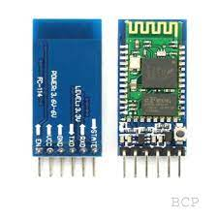



**Fig 3.2 Bluetooth Module (HC 06)**

#### RELAY



Relays serve as indispensable components in a multitude of electronic systems, offering a pivotal mechanism for controlling high-power circuits with low-power signals. At the heart of their operation lies an electromagnet, activated by a small electrical signal applied to the relay coil. This signal generates a magnetic field, compelling a movable armature to alter the position of the switch contacts within the relay. Figure 3.3 depicts the 5V relay configuration encompasses essential pins: Input Voltage (VCC), commonly set to 5V to energize the relay coil, and the Ground (GND), establishing the circuit's reference point. Additionally, the relay features three pivotal contacts: the Normally Open (NO) and Normally Closed (NC) contacts, alongside the Common (COM) terminal. These contacts facilitate the switching of circuits, remaining open or closed depending on the relay's energized state. When the control signal energizes the relay coil (VCC), the magnetic field propels the switch contacts, either opening or closing the circuit, thus enabling remote control of connected loads. This operational versatility finds application across diverse domains, including home automation, industrial control systems, automotive electronics, and beyond, where the need to efficiently manage high-power devices with minimal control signals is paramount.

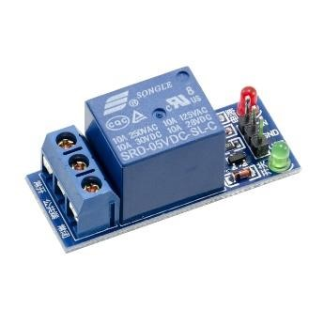

**Fig 3.3 Relay**

#### SINGLE PHASE AC MOTOR

A single-phase AC motor is a type of electric motor that operates on a single-phase alternating current (AC) power supply. Unlike three-phase motors, which are commonly used in industrial applications, single-phase motors are often found in household appliances, small machinery, and other low-power applications. They feature a start winding and a run winding, along with a centrifugal switch to disconnect the start winding once the motor reaches a certain speed. Capacitor-start motors, also known as capacitor-start, capacitor-run motors, are similar to split-phase motors but incorporate a capacitor in series with the start winding. The capacitor provides a phase shift, improving starting torque and efficiency. Figure 3.4 operates using the principle of electromagnetic induction and feature a shaded pole on the stator to create a phase shift. Single-phase AC motors are relatively simple in design compared to three-phase motors, making them cost-effective and suitable for low-power applications. Single-phase AC motors are relatively simple in design compared to three-phase motors, making them cost-effective and suitable for low-power applications. Single-phase motors are typically fixed-speed motors, meaning their speed is determined by the frequency of the AC power supply. However, some motors may incorporate speed control methods such as changing the voltage or using electronic speed controllers.

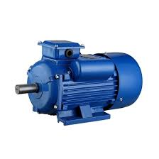

**Fig 3.4 Single Phase AC Motor**

**CHAPTER 4**

## PROPOSED METHOD

### 4.1 BLOCK DIAGRAM

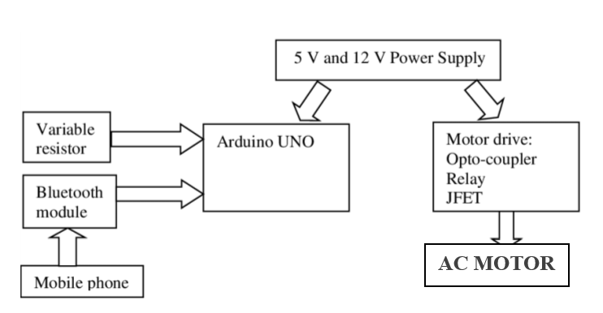Bluetooth module receives commands from a Arduino Bluetooth serial communication application in a smartphone and sends control message to Arduino Uno. Arduino Uno controls the relay module, which manages the AC motor's power. Figure 4.1 depicts the block diagram of automatic shutter opening. The AC motor is powered from the mains and controlled by the relay.

**Fig 4.1 Block Diagram of automatic shutter opening**

### 4.2 WORKING

An automatic shutter opening system using Arduino Uno, HC-06 Bluetooth module, relay, and a single-phase AC motor involves a combination of hardware connections and software programming. It reads commands from the HC-06 Bluetooth module and controls the relay to activate the motor. The HC-06 module allows wireless communication between a smartphone or computer and the Arduino Uno. It receives commands from a Bluetooth-enabled device and sends them to the Arduino for processing. The relay acts as a switch to control the single-phase AC motor. When triggered by the Arduino, it connects or disconnects the motor from the power supply, thereby opening or closing the shutter. The motor is responsible for physically opening and closing the shutter. It is connected to the relay, which controls its operation based on commands received from the Arduino. Initialize communication with the HC-06 Bluetooth module. Continuously listen for incoming commands from the Bluetooth module. Interpret the received commands and trigger the relay accordingly. Implement safety features and error handling mechanisms. Provide feedback to the user via LEDs or serial communication. Define a simple communication protocol between the Bluetooth module and the Arduino Uno. For example, sending specific characters or strings to indicate commands such as "open" or "close." Ensure that the smartphone or computer is paired with the HC-06 Bluetooth module. Using a Bluetooth terminal app or custom mobile application, send commands (e.g., "open" or "close") to the HC-06 module. If the command is "open," the Arduino triggers the relay to connect the motor to the power supply, causing the shutter to open. If the command is "close," the Arduino triggers the relay to disconnect the motor, causing the shutter to close. Implement safety features to prevent accidental operation or damage to the system, such as timeout limits, position sensors, or emergency stop buttons.

**CHAPTER 5**

## RESULTS AND DISCUSSION

The automatic shutter opening system successfully integrates an Arduino Uno, HC-06 Bluetooth module, relay, and single-phase AC motor to enable wireless control of a shutter. The system's functionality allows users to send commands from a smartphone or computer via Bluetooth, initiating the opening or closing of the shutter. Upon receiving a command, the Arduino interprets it and triggers the relay to connect or disconnect the motor, resulting in the desired action. Safety features, such as timeout limits and emergency stop buttons, enhance the system's safety and reliability. Feedback to the user, provided through LEDs or serial communication, effectively indicates the system's status, ensuring that users are informed about the shutter's operation. Overall, the automatic shutter opening system demonstrates a successful integration of hardware and software components, offering a convenient and efficient solution for controlling shutters in various applications.

The automatic shutter opening system utilizes an Arduino Uno, HC-06 Bluetooth module, relay, and single-phase AC motor to wirelessly control the shutter's movement. The system's operation begins with the Arduino initializing communication with the HC-06 Bluetooth module. Figure 5.1 depicts the user interface for communication with Bluetooth module(HC 06) via android application. It continuously listens for incoming commands, such as "open" or "close," sent from a paired smartphone or computer via Bluetooth.

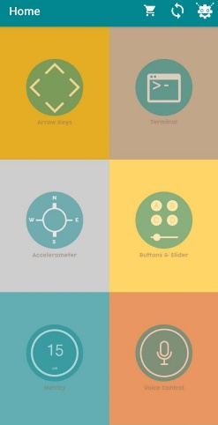

**Fig 5.1 User interface**

When a command is received, the Arduino interprets it and triggers the relay accordingly. Figure 5.2 depicts the Hardware Setup automatic shutter opening. For example, if the command is "open," the relay connects the motor to the power supply, causing the shutter to open. Conversely, if the command is "close” causing the shutter to close.

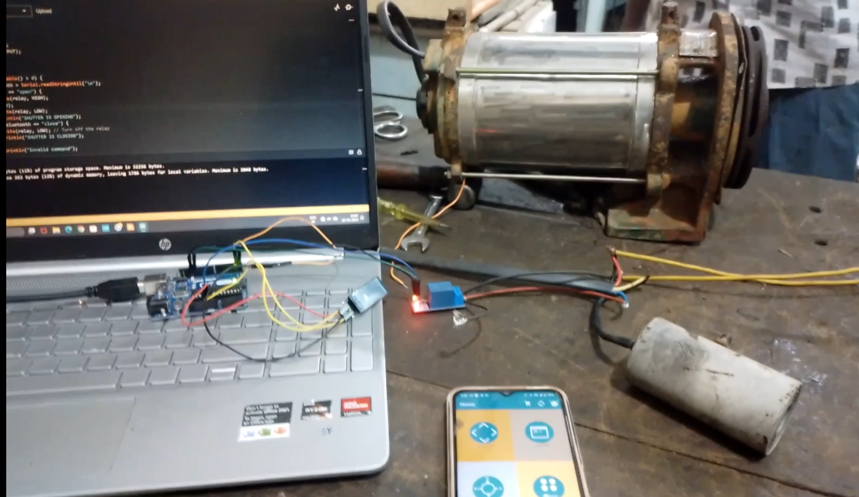

**Fig 5.2 Hardware Setup**

**CHAPTER 6**

## CONCLUSION AND FUTURE SCOPE

### 6.1 CONCLUSION

Using parts like an Arduino, relay module, Bluetooth interface, and AC motor to build an automatic shutter opener is an example of creativity and problem-solving. Throughout the project, safety is a key component that emphasizes the responsibility of handling electrical components, especially AC voltage. Following strict safety procedures guarantees the system's lifetime and dependability in addition to providing protection against possible risks. Making safety a top priority demonstrates the dedication to developing a solution that is not only practical but also safe for the environment and people.

### 6.2 FUTURE SCOPE

The project of automatic shutter openers has a great deal of potential for growth and development in the future. As technology develops further, a number of exciting new directions for application arise.

The functioning of the system might be completely transformed by utilizing automation and artificial intelligence (AI). The system could learn user preferences and automatically modify shutter operations based on different factors like weather, occupancy patterns, and energy efficiency goals by implementing AI algorithms and machine learning techniques. This would optimize energy usage and improve user comfort. For instance, the system might automatically move the shutters to optimize natural lighting while reducing heat gain or loss depending on the time of day and the quantity of sunshine entering the space.

## 

## REFERENCES

[1] A. Szczurek and J. Cholewa, "Design of automatic roller shutter control system," 2016 21st International Conference on Methods and Models in Automation and Robotics (MMAR), 2016.

[2]. Chingan, V. Cojocaru, and I. Gorgan, "A low-cost automatic shutter control system," 2017 International Symposium on Signals, Circuits and Systems (ISSCS), 2017.

[3] M. A. Hossain, M. A. Matin, and M. N. Islam, "Design and implementation of an automatic shutter control system for daylight harvesting," 2015 International Conference on Electrical Engineering and Information Communication Technology (ICEEICT), 2015.

[4] S. S. Kumar and S. P. Kumar, "Automatic shutter control system using Arduino," 2016 International Conference on Wireless Communications, Signal Processing and Networking (WiSPNET), 2016.

[5] S. K. Ghosh, S. K. Halder, and S. K. Pal, "Automatic control of rolling shutters with under-voltage protection," 2017 International Conference on Power, Energy and Environment: Towards Smart Technology (ICEPE), 2017.

[6] T. B. Bhattacharya and S. R. Bhattacharjee, "Design and implementation of automatic shutter control system using PLC," 2018 International Conference on Control, Power, Communication and Computing Technologies (ICCPCCT), 2018.

[7] S. S. Mishra, A. K. Singh, and P. K. Singh, "Automatic shutter control system based on solar intensity," 2019 International Conference on Sustainable Computing in Science, Technology and Management (SUSCOM), 2019.

**ANNEXURE**

**ACCEPTANCE LETTER**

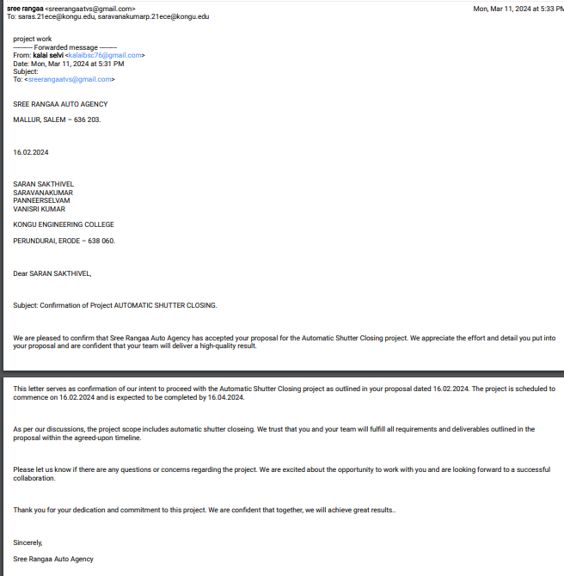

**APPRECIATION LETTER**

